**CSA0564 - DATABASE MANAGEMENT SYSTEMS FOR QUERY PROCESSING**

**ANONYMOUS BLOCKS :**

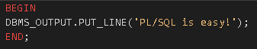

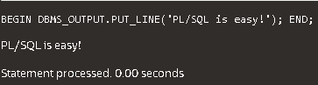

**DECLARATIVE AND EXECUTABLE SECTIONS :**

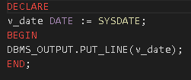

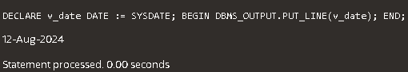

**DECLARATIVE, EXECUTABLE AND EXCEPTION SECTIONS :**

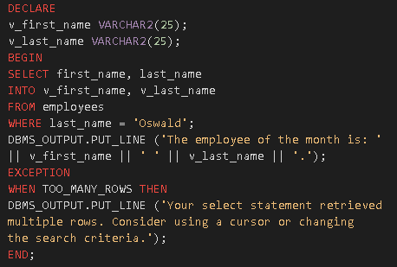

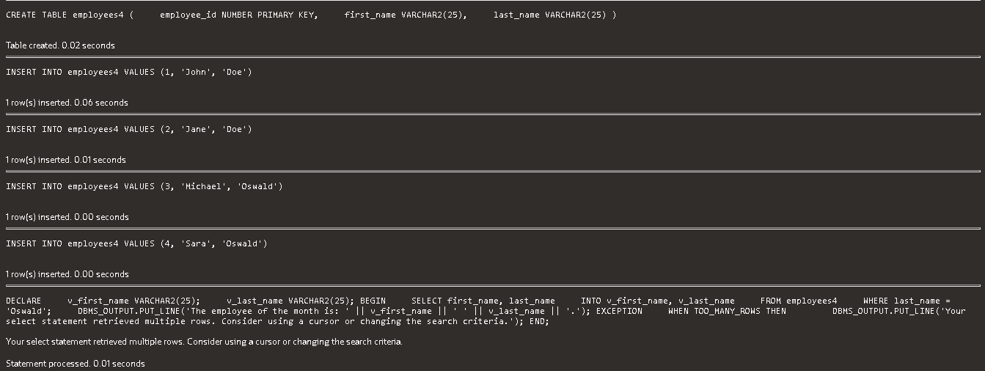

**EXAMPLE 1 :**

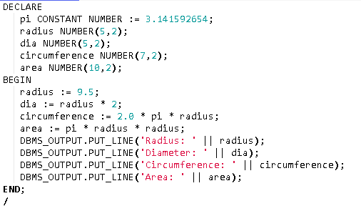

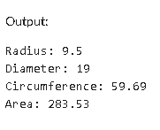

**EXAMPLE 2 :**

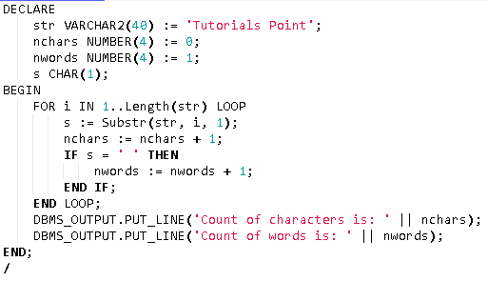

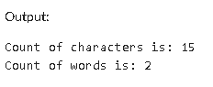

**SUBPROGRAM CODE BLOCKS :**

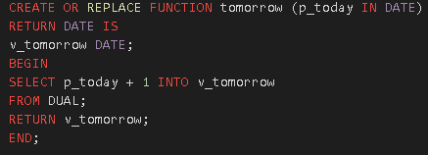



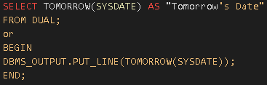



**ARRAY PROGRAM :**

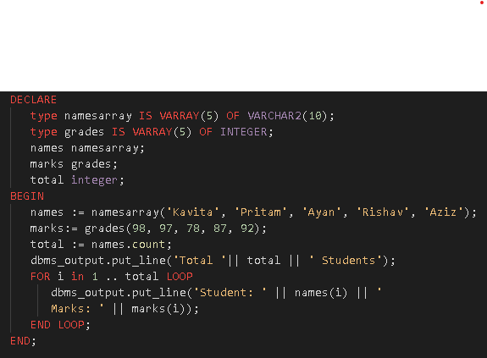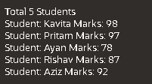

**COUNT OF ODD AND EVEN DIGITS IN A SEQUENCE OF NUMBER :** 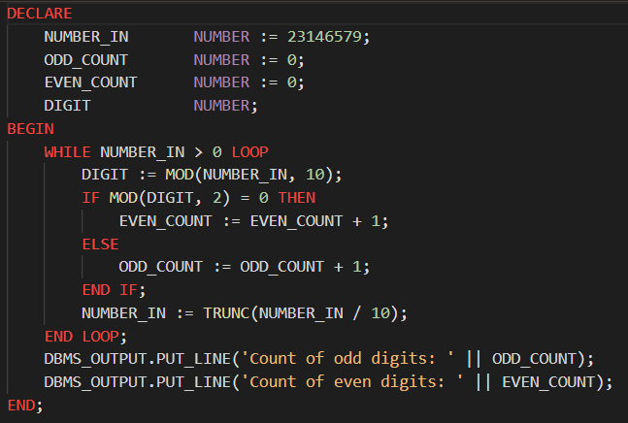

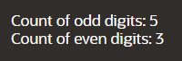

**FACTORIAL USING FUNCTIONS :**

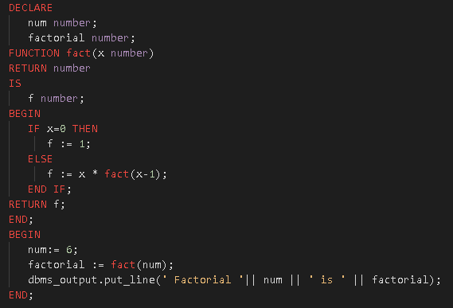



**MAXIMUM OF TWO NUMBERS :**

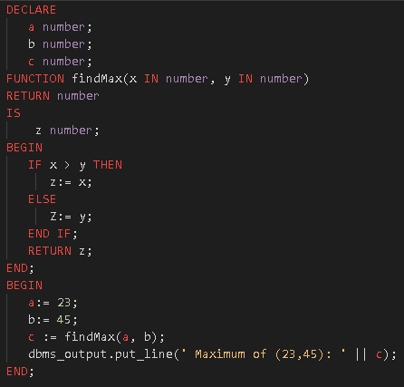



**FIBONACCI USING RECURSION :**

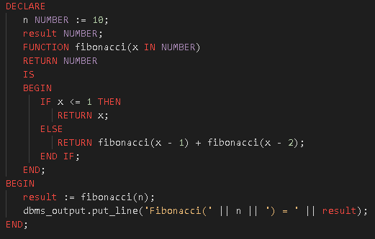



**CURSOR FUNCTION :**

